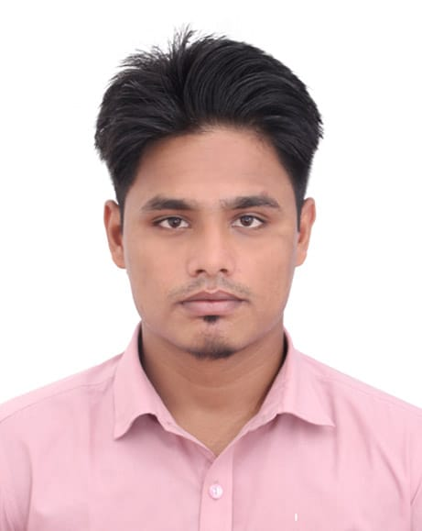

Md Afiz Ali

# EDUCATION

* Md. Afiz Ali
* Bawanpur, Islamabad, Bishwanath, Sylhet

● +8801741-368171

* [afizali327@gmail.co](mailto:afizali327@gmail.co)m

**SK****ILS**

MS Office Photoshop E-mail Internet

|  |  |  |  |  |
| --- | --- | --- | --- | --- |
|  |  |  |  |  |
|  |  |  |  |  |
|  |  |  |  |  |
|  |  |  |  |  |

# BA (Honors.)

Year of Passing :2018

Date of Issuance of Certificate : September 9, 2018

Result : CGPA 3.03 (out of 4)

Institution : MC College, Sylhet.

Major : Bangla

Awarding Body : National University

# HSC (Higher Secondary Certificate)

Year of Passing : 2013

Date of Publication of Result : August 03, 2013

Result : GPA 4.50 (out of 5)

Institution : Shah Khurrom Degree College, Sylhet.

Group : Humanities

Awarding Body : Sylhet Board

# Dakhil

Year of Passing :2011

Date of Publication of Result : May 12, 2011

Result : GPA 4.94 (out of 5)

Institution : Sohifagonj S.D Mardrasah

Group : Science Awarding Body : Madrasah

COMMUNICATI ON

|  |  |  |  |  |
| --- | --- | --- | --- | --- |
|  |  |  |  |  |
|  |  |  |  |  |
|  |  |  |  |  |
|  |  |  |  |  |
|  |  |  |  |  |

ORGANIZATION TEAM PLAYER CREATIVITY SOCIAL

# 

**PERSONAL**

# Experience

**As a Marketing Executive:** I have worked at Mohanogor Hospital, Sylhet as a Marketing Executive from 1st October, 2018 to till now.

**Name: Md. Afiz Ali**

**Father : Md. Montaz Ali Mother : Nawarun Nesa**

**Date of Birth : April 01, 1994**

**Nationality : Bangladeshi National ID : 8201645440 Religion : Islam**

**Sex : Male Marital Status: Single Blood Group : B (+ve)**

**Guardian’s Information**

**Na****me**

Md. Akbor Ali

**Phone**

+8801731374721

**Relation**: Brother

# Self Appraisal

* Excellent hands on Management & Communication

**Personal Information**

* Organizing and leadership competence.
* Able to analyze and interpret complex information.
* Helpful and innovative willingness to work in team.
* Able to deal with highly confidential matters professionally & discreetly.
* Can learn quickly the necessary details of work.
* Be patient, tactful, diplomatic and approachable.
* Flexible to adopt new environment quickly
* Time Management & Presentation Skill
* Ability to Work Under Pressure

# Reference

**Name :** Sheikh Md. Najrul Islam **Position** : Assistant Professor

**Institution :** MC College, Sylhet

**Phone :** +8801716-826112

**E-mail :** [najrul78mc@gmail.com](mailto:najrul78mc@gmail.com)

**Name :** Dr. Shaheda Akhter

**Position** : Associate Professor

**Institution :** MC College, Sylhet

**Phone :** +8801552438808

**E-mail :** [dr.shahedaakhter@gmail.com](mailto:dr.shahedaakhter@gmail.com)

I do hereby declare that all above information is true and correct to the best of my knowledge. I authorize the respective authority to verify the information provided in this resume.

Sincerely,

# Md. Afiz Ali